**M5 - PROJECT 5**

**Name: Sunil Raj Thota**

**NUID: 001099670**

**Date: 10/14/2020**

**Title: M5 Project 5 Executive Summary Report**

**ALY 6000 - 71618 (CRN Number)**

**Prof. Dee Chiluiza Reyes**

**Introduction:**

Big Data Analytics can predict evolving trends, target the precise customer at the right time, the decline in marketing expenses, and raise the standard of customer service. Usually, retailers are customer-focused and customer-driven. They know what their customers require. They're qualified enough to be focused and well-mannered. They're stimulated to get profound product knowledge so they'll aid customer requirements. Proper feedback from customers helps outline upcoming marketing plans and store actions. The massive Data and Retail Industry revolution have shown that leading companies are using data to run their total businesses and operations. Tt's become so widespread and available that more retail brands than ever are trusting on data-driven insights to enhance pricing, update operations, and ameliorate the full customer experience.

**Industry Analysis:**

The above chart shows that the most preferred data technologies used by retailers are Data Visualization, Location-based, Big Data, In-store Sensors, and ML/ AI to stay on top of the game and gain huge share in the markets.

With the help of huge data collection from the customers the retail companies are planning to implement few advanced ways of buying their products. These large sets of shopper’s data can be applied to allow vendors to predict upcoming behaviour, and based on such forecasts, tailor the finest customer suggestions or behaviours to cooperate with customers or dealers. Customer favourites and customization transfers particularly great weightage in this industry.

I would like to work as a Data Analyst in the Retail Industry to start my career initially and then slowly to excel as a Data Scientist. In which, I can involve in myself in various teams and stakeholders to work on models, recommendation systems, future aspects, developing algorithms, implementing strategies to make choices that in turn improves the businesses.

The most influenced product categories are Electronics and Apparel where they two handles almost around 46% of the market share. This showcases the people’s views on their purchasing interests. And, the Age groups of 18 – 20, and 21 – 34 holds around 75% of their influence on the retail industry.

Data Analytics domain shows significant impact on customer interactions and enhancements particularly in the retail sector. This data will improve in subsequent applications of retail industry and provides various insights which defines the goals and sales of a company. We mostly use data models that are built by diverse algorithms and models to pursuit for outlines and relations in the data by means of numerous data mining methods. This creates a probability for new customer relations.

The above graph shows the exponential growth in using big data analytics in Retail industry and the expected revenue generated is about 2.25 Billion dollars and it is forecasted about 4.5 Billion dollars by 2025. So, there is growth and demand in this industry where one can excel their career prospects in this.

We can make use of these techniques to develop direct/ indirect marketing campaigns, advertisements, personalized customer discounts, ameliorating customer experience, customer retention, predicting future demand and supply, and level up the stocks, inventory, and warehouses with necessary resources.

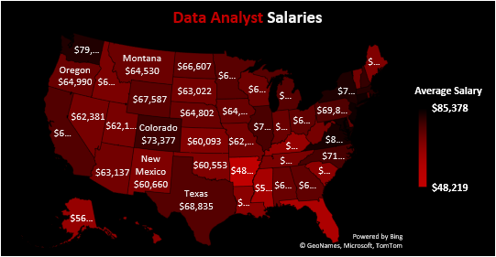

The above map shows the average data analyst salaries in USA which is plotted state-wise to provide an idea how a data analyst is earning and can make some good amount of money by improving their skills.

**Conclusions:**

Big Data Analytics is playing and will definitely plays a vital part in determining the upcoming retail industry. The big data revolution is going to set new standards and will become the future of retail and other industries. An efficient supply chain, an enhanced drive of goods from dealers to silos to stores to the shopper, is very serious in every business. So, big data analytics is so essential of transforming retail industry and excels in real-time, leveraging customer data to envisage purchasing forms.

**References:**

1. Big Data Analytics in Support of the Decision Making Process, by Nada Elgendy & Ahmed Elragal [www.sciencedirect.com/science/article/pii/S1877050916324206](http://www.sciencedirect.com/science/article/pii/S1877050916324206)
2. Big Data and Analytics in Retailing by Venky Shankar, [www.researchgate.net/publication/332795401_Big_Data_and_Analytics_in_Retailing](http://www.researchgate.net/publication/332795401_Big_Data_and_Analytics_in_Retailing)
3. Big Data Analytic: New mode of retail intelligence for revenue growth by Amarjeet Singh, <https://www.irjet.net/archives/V3/i8/IRJET-V3I8357.pdf>
4. Impact Of Data Science On Retail Industry, <https://www.proschoolonline.com/blog/impact-of-data-science-on-retail-industry>
5. Disruptions in Retail through Digital Transformation Reimagining the Store of the Future by S Kannan, <https://www2.deloitte.com/content/dam/Deloitte/in/Documents/CIP/in-cip-disruptions-in-retail-noexp.pdf>
6. Big Data Analytics in Retail Market - Growth, Trends and Forecast (2020 - 2025), https://www.mordorintelligence.com/industry-reports/big-data-analytics-in-retail-marketing-market